PROTOTYPING

7 ‘R’ questions to help us choose prototypes
- Is it Relevant ?
- Is it Revolutionary ?
- Is it Rapid ?
- Is it Rough ?
- Is it Right ?
- Is it Relationally effective ?
- Is it Replicable ?

The Pentagon of Prototyping
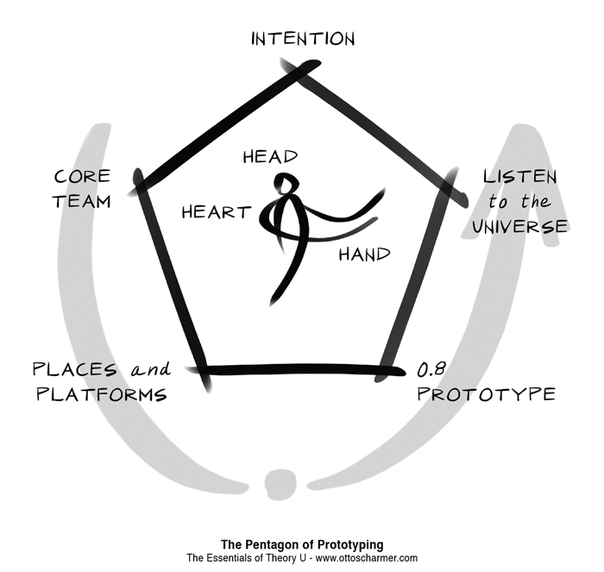

10 Questions to help us Prototype
- What is the idea / inquiry ?
- Who is the core team ?
- What are possible leverage / acupuncture points ?
- What will inspire energy ?
- What would help give us a sense of direction and a sufficient sense of safety ?
- What places / support infrastructure might be most useful to help us on our path forward ?
- Who can help ?
- What might be good milestones for reviewing progress and learning ?
- How can we support and encourage a feedback-rich system ?
- What might be an emerging leadership narrative ?

Further resources
Details of U Lab MOOC and other resources at www.presencing.org
To find out more about Theory U in Ireland, talk to Chris or Jimmy
To find out more about U Lab in Scotland, talk to Valerie

