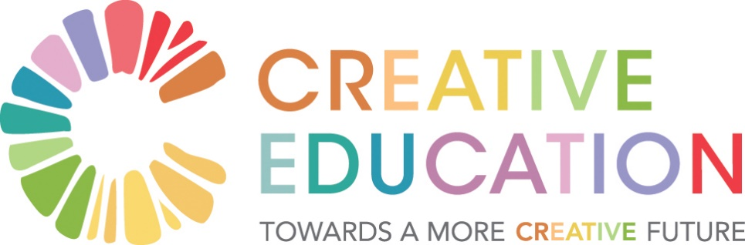

Prototypes from Symposium
Frame: Participants chose to work on 10-20 projects with the assistance of others to explore if they met the 7R’s test: relevant, revolutionary, rapid, rough (80% thought through), right (for context and circumstances), relationally effective and replicable. The following prototypes are arranged thematically.

Process-based Prototypes
1. Wild Atlantic Way of Education (WAWE): The vision is of a network of places radiating from a mother hub to places such as Galway, Burren, Limerick and Cork that would crack open the possibility of local conversations for parents, teachers, students and others and would generate waves of ongoing conversation such that we would never again speak of a 20-year old curriculum. It would embrace the power of the Irish landscape and provide an ethos devoid of high profile politics, gender or religion. Stakeholders would come together in a safe way to harness and extend authentic education through a variety of mediums and for a variety of learners and educators. It would provide leadership and a cascading of values and actions. The WAWE would have branding and quality assurance and provide a signpost to where the learning/conversational experience was available – for parents, teachers and students or combinations of these – thus propagating the conversation process.
2. Citizens Assembly for Educational Reform: This formula needs to be applied to education in order to garner citizen support and Government buy-in for the reforms that are necessary. Should this be issues or policy-based – e.g. reform of SC, transition from primary, patronage, admissions/selection policies at each level of education – points system, assessments? Timeline: 2020 – 18 months; Buy-in – Government, DES, Education Partners, NCCA; Sponsor – perhaps Creative Ireland? Methodology: similar to recent Citizens Assembly – voice of young people, focus groups; Design Team – to refine questions, to identify expert witnesses, national and international experts, to select participants; Role of deliberative democracy experts. Recommendations to inform legislation – model for education rather than policy? Policy rather than philosophy? Redefine the SC; how do select students for post second-level and what reforms are necessary? Focus on knowledge or skills? (Is fairness a flawed concept?) [Contact Tom Arnold; include student voice; focus on diversity; this ties in well with the reflective space for whole schools – provides a mechanism to listen to and hear voices; concrete and aiming for attunement between participants to grow.]
3. BCA/Burren – a Sane Space: There are opportunities for BCA being a space for nurturing the personal and professional development for Leaders in Higher Education – a home for reflective practice and UDL (universal design for learning). It can be an anchor and connector for process-based approaches moving forward, a place for sustaining a community of disruptors. Create an online platform to allow connection between on- site work. It can also be a show-case for innovative work in education supported by SIFI and a node on the WAWE.

Teacher-focused Prototypes
3. Re-imagining Teacher Education: There are insufficient entrants and insufficient diversity – students need to see a diverse teacher cohort. The lengthening of the course and the attendant expense has exacerbated the diversity challenge. The ‘Path Project’ only applies in class and then only for disability and the traveller community. Potential blockages include: Irish language; the short-sightedness of the HEA; new communities don’t draw from the same well. This is the moment – Universities have no choice, they must make investment.
4. Teaching through Mentoring: Everyone becomes a mentor and a learner, trusting self and other. Generosity and sharing build social capital. To be viable it requires a shared interest and consistent commitment to the long-term. The teacher is facilitator of learning and content skills. There needs to be space – ‘sos’ – for this work and the quality of the mentor is crucial. Tribes.com – mentoring in which each tribe has responsibility to ensure everyone achieves learning outcomes, the student is connecting the dots, developing human potential, active listening with mutual respect, students become more responsible and develop leadership and communications skills, there is a collective responsibility for everyone to figure things out.

Learning-focused Prototypes
5. Teaching and Learning for an Unknown Future: We need phenomenon-based learning that is authentic and relevant to current crisis of climate change and other ‘wicked problems’. Students need to learn about how to use subjects – skill-based. We are in an age of AI and new technologies causing a change of the type of jobs that will be needed in the future.
6. AI-based Learning: Technology-enhanced learning can be built on the basis of the current education system as a personalised learning experience. AI-based resources that are used in class are available on an ongoing basis after the lesson to all students. The teacher sparks the desire to learn. The student can learn online using an application, anywhere, anytime. Students can be assessed automatically on their work, identifying their weaknesses and how to improve. Technology augments but doesn’t replace the teacher. The technology is already here now – it’s not a hundred years away. [Ethics with robots vs humans? I like that it gives the student greater agency. I love the teacher inspiring a life-long love of learning.]
7. Online Learning for Greater Opportunities: The rapid advance of AI will replace lots of jobs. Technology needs to be integrated into schools creating a virtual environment – teacher and student, separate but connected. Connect online opportunities to the community, develop off-line and present as part of SC options which are rewarded and recognized. Online can be used for documenting reflection and building portfolio. [Resources offered: Alison.com – free online training; Khan Academy; Lynda.com;]

8. Place-based learning (PBL): Preparing people for the real world through engaging in learning in their native place. The PBL concept is about using the world as a classroom, serving humanity (vs industry) – not the world as it is but as it might be. Curing the sense of displacement, of being in exile/refugee in one’s own place. PBL entails social innovation contribution to community wellbeing. It needs to be integrated into the JC curriculum with teacher training about place – the teacher as inter-active facilitator enabling learning. [In Germany all students do exams about their local place/geography.]

Education of the Heart/Whole Person
9. Life of the Heart: This involves the ethos and values of schools – actions and behaviours, tone and language; emotional literacy, a journey from age 4 to 18 years. It involves the whole school body placing value on the language of the heart. It needs to inform the work of the principal, the guidance counsellor, staff meetings, the parents association as well as parent/teacher, principal/teacher and teacher/student engagements. As a way of being it needs action and articulation by a group of passionate teachers and students. Feelings are celebrated and talked about without repercussions and judgment with support from principal and guidance counsellor. There is time and space (e.g. at end of circle time) and it engenders a community feeling which nurtures the child’s development. [How to model making vulnerability OK? It needs to start in primary school. Would love to link this to whole school reflection. This needs to be vital to all schools moving forward].
10. Vulnerability: This can’t be taught. It requires living the life of the heart.
11. Advocating for the Less-heard Voices: In TY run focus group starting with non-controversial subjects such as ‘Is being vegetarian better for your health?’ Introduce methods for respectful listening and provide ways to express each voice – movement, art, music, dialogue etc. [Try circle time. Who are the lesser-heard voices?]
12. Whole-school reflective space: Reflection should be built-in not an add-on, an engine not a carriage. Active listening, reflection and relationship building need to be core skills. Democratic practice is needed in the classroom and the reflection room. We need to model and teach these skills

Student-focused Prototypes
13. Students Year - Surveys that represents how Students really feel: Canvas changing the name of Transition Year, to which a stigma attaches, to Students year. The Students Year creates a board that collates ideas from sources such as this Symposium for implementation in Student Year. Surveys conducted in accordance with a National Survey Organisation (NSO) would ensure ‘gold standard’ - unbiased and non-commercial. Diverse groups of young people would write the questions to help inform developments in education. It would allow students to believe it doesn’t have to be this way – what could school be for you? Surveys measure students’ views on programmes in Student Year. [Check out ‘So how was school today?’ – largest survey on students’ opinions on school. Check out ‘My World Survey’ – does this provide some of this information? Why a survey – why not a collection of voices/stories? Great idea – then I wonder what will emerge from the survey? Give students voice on the school Board. Values/education – what is it? What are feelings? How to teach it and who teaches it.12]
14. School is out for Now: There is disaffection among many students. There needs to be the possibility of taking leave-of-absence for periods for work experience with the possibility of returning to education with a sense of purpose. The criterion is being ready for learning with the help of mentors. The scary question is: ‘Do we need schools?’

Physical Design of Schools for New Era
15. Re-design School Spaces/Architecture: Change the physical structure of schools to enable flow and collaboration (and fun). They should be purpose-specific and multi-functional, addressing outdoor spaces and car-parks as well as class-rooms, community facilities, medical centre etc. The DES building unit as well as the ETB, local communities, school leadership students and teachers and the inspectorate (from a teaching and learning perspective) need to be involved. Creativity and energy are needed in getting buy-in for good design which attends to light and sustainability (energy neutral, solar energy, rain-water harvesting, recycling bins). Taking time to listen pays dividends for learning outcomes, wellbeing and community relationships. Have one shared room for every 4 classrooms as in Finland. [Energy efficient kitchens, green space, community gardens, light; I’ll take it to NUIG and Dublin school of architecture. Doors, windows and thresholds are crucial; look to Scotland as an example; flexible space and rooms – no offices; ownership of space – teams.]

